Greek Numeral System
# Source: AI Source: Provided by: [Data Path: Persons Table -> ID Column: 1, Name_En Column: Motasem Essam] -> From: [ChatGPT] on [7/16/2026]
The Greek Numeral System is a non-positional numeral system developed in ancient Greece that represents numbers using letters of the Greek alphabet. Each letter has a fixed numerical value, and numbers are formed by combining these letters according to additive rules.
The most widely used Greek numeral system is the Ionic (Milesian) Numeral System, introduced around the 4th century BCE. It replaced the earlier Attic (Acrophonic) Numeral System and remained in use for centuries.
Unlike positional numeral systems such as decimal or binary, the Greek numeral system does not use place value or a base (radix).

Definition
# Source: AI Source: Provided by: [Data Path: Persons Table -> ID Column: 1, Name_En Column: Motasem Essam] -> From: [ChatGPT] on [7/16/2026]
The Greek Numeral System is a non-positional numeral system in which letters of the Greek alphabet are assigned fixed numerical values.
Numbers are represented by combining these letters, and the total value is obtained by adding the values of the individual symbols.

Type of Numeral System
# Source: AI Source: Provided by: [Data Path: Persons Table -> ID Column: 1, Name_En Column: Motasem Essam] -> From: [ChatGPT] on [7/16/2026]
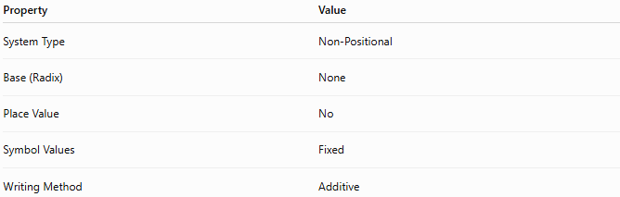
Property | Value
System Type | Non-Positional
Base (Radix) | None
Place Value | No
Symbol Values | Fixed
Writing Method | Additive

Basic Principle
# Source: AI Source: Provided by: [Data Path: Persons Table -> ID Column: 1, Name_En Column: Motasem Essam] -> From: [ChatGPT] on [7/16/2026]
Each Greek letter represents a specific numerical value.
Numbers are formed by:
- Selecting the appropriate letters.
- Adding their numerical values.
The position of a letter does not change its value.

Greek Numeral Symbols (Ionic / Milesian System)

Units
# Source: AI Source: Provided by: [Data Path: Persons Table -> ID Column: 1, Name_En Column: Motasem Essam] -> From: [ChatGPT] on [7/16/2026]
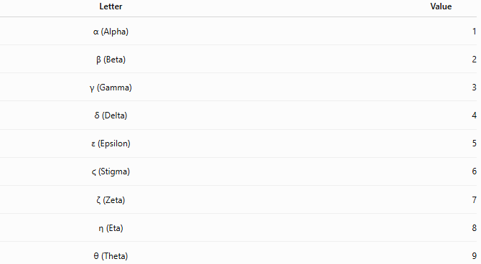
Letter | Value
α (Alpha) | 1
β (Beta) | 2
γ (Gamma) | 3
δ (Delta) | 4
ε (Epsilon) | 5
ϛ (Stigma) | 6
ζ (Zeta) | 7
η (Eta) | 8
θ (Theta) | 9

Tens
# Source: AI Source: Provided by: [Data Path: Persons Table -> ID Column: 1, Name_En Column: Motasem Essam] -> From: [ChatGPT] on [7/16/2026]
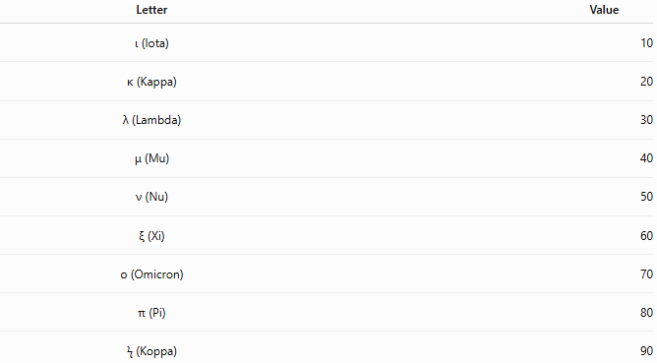
Letter | Value
ι (Iota) | 10
κ (Kappa) | 20
λ (Lambda) | 30
μ (Mu) | 40
ν (Nu) | 50
ξ (Xi) | 60
ο (Omicron) | 70
π (Pi) | 80
ϟ (Koppa) | 90

Hundreds
# Source: AI Source: Provided by: [Data Path: Persons Table -> ID Column: 1, Name_En Column: Motasem Essam] -> From: [ChatGPT] on [7/16/2026]
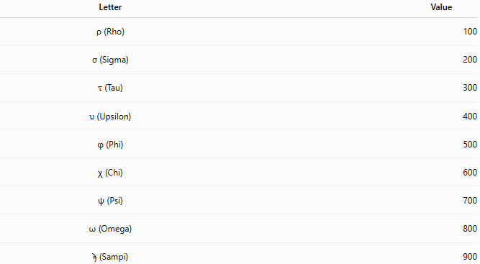
Letter | Value
ρ (Rho) | 100
σ (Sigma) | 200
τ (Tau) | 300
υ (Upsilon) | 400
φ (Phi) | 500
χ (Chi) | 600
ψ (Psi) | 700
ω (Omega) | 800
ϡ (Sampi) | 900

Thousands
# Source: AI Source: Provided by: [Data Path: Persons Table -> ID Column: 1, Name_En Column: Motasem Essam] -> From: [ChatGPT] on [7/16/2026]
Thousands are indicated by placing a lower-left mark (͵) before the letter.
Examples:
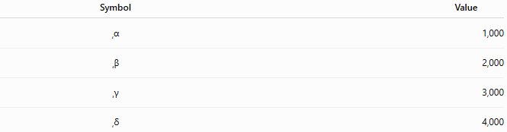
Symbol | Value
͵α | 1,000
͵β | 2,000
͵γ | 3,000
͵δ | 4,000

Writing Numbers
# Source: AI Source: Provided by: [Data Path: Persons Table -> ID Column: 1, Name_En Column: Motasem Essam] -> From: [ChatGPT] on [7/16/2026]
Numbers are formed by adding the values of the symbols.

Example 1
Number
$$12$$
Representation
$$ιβ$$
Calculation
$$10+2=12$$

Example 2
Number
$$345$$
Representation
$$τμε$$
Calculation
$$300+40+5=345$$

Example 3
Number
$$2026$$
Representation
$$\text{͵}βκ\text{ϛ}$$
Calculation
$$2000+20+6=2026$$

Characteristics
# Source: AI Source: Provided by: [Data Path: Persons Table -> ID Column: 1, Name_En Column: Motasem Essam] -> From: [ChatGPT] on [7/16/2026]
The Greek numeral system:
- Is non-positional.
- Uses alphabetic symbols.
- Assigns fixed values to each letter.
- Uses additive notation.
- Does not use place value.
- Does not have a positional base.

Zero
# Source: AI Source: Provided by: [Data Path: Persons Table -> ID Column: 1, Name_En Column: Motasem Essam] -> From: [ChatGPT] on [7/16/2026]
The classical Greek numeral system did not include a symbol for zero.
Zero entered Greek mathematics later through influence from other mathematical traditions, particularly the Indian numeral system.

Negative Numbers
# Source: AI Source: Provided by: [Data Path: Persons Table -> ID Column: 1, Name_En Column: Motasem Essam] -> From: [ChatGPT] on [7/16/2026]
The Greek numeral system was not intended to represent negative numbers.
It was designed primarily for counting, measurement, and record keeping.

Fractions
# Source: AI Source: Provided by: [Data Path: Persons Table -> ID Column: 1, Name_En Column: Motasem Essam] -> From: [ChatGPT] on [7/16/2026]
The Greeks developed several methods for writing fractions, separate from the main numeral system.
These methods varied over time and were especially used in astronomy and mathematics.

Advantages
# Source: AI Source: Provided by: [Data Path: Persons Table -> ID Column: 1, Name_En Column: Motasem Essam] -> From: [ChatGPT] on [7/16/2026]
The Greek numeral system:
- Represents numbers compactly.
- Uses familiar alphabetic symbols.
- Is suitable for inscriptions and manuscripts.
- Was effective for commerce and administration.

Disadvantages
# Source: AI Source: Provided by: [Data Path: Persons Table -> ID Column: 1, Name_En Column: Motasem Essam] -> From: [ChatGPT] on [7/16/2026]
The Greek numeral system:
- Lacks place value.
- Does not naturally represent zero.
- Makes arithmetic calculations difficult.
- Is unsuitable for modern computation.
- Requires knowledge of specialized symbols such as Stigma (ϛ), Koppa (ϟ), and Sampi (ϡ).

Applications
# Source: AI Source: Provided by: [Data Path: Persons Table -> ID Column: 1, Name_En Column: Motasem Essam] -> From: [ChatGPT] on [7/16/2026]
Historically, the Greek numeral system was used in:
- Mathematics
- Astronomy
- Commerce
- Government records
- Religious manuscripts
- Book numbering
- Chapter numbering
- Historical documents
- Coins
- Monument inscriptions

Modern Uses
# Source: AI Source: Provided by: [Data Path: Persons Table -> ID Column: 1, Name_En Column: Motasem Essam] -> From: [ChatGPT] on [7/16/2026]
Today, Greek numerals are still occasionally used for:
- Chapter numbering
- Lists and outlines
- Historical references
- Ecclesiastical numbering
- Traditional scholarly works

Common Mistakes
# Source: AI Source: Provided by: [Data Path: Persons Table -> ID Column: 1, Name_En Column: Motasem Essam] -> From: [ChatGPT] on [7/16/2026]
- Assuming Greek numerals use place value.
- Confusing Greek numeral letters with Roman numerals.
- Forgetting the special numeral letters (ϛ, ϟ, ϡ).
- Assuming the system has a base like decimal or binary.

Key Points
# Source: AI Source: Provided by: [Data Path: Persons Table -> ID Column: 1, Name_En Column: Motasem Essam] -> From: [ChatGPT] on [7/16/2026]
- The Greek numeral system is non-positional.
- It uses letters of the Greek alphabet as numerals.
- Each letter has a fixed numerical value.
- Numbers are formed by adding the values of the letters.
- There is no place value or positional base.

Greek Numeral System vs. Decimal System
# Source: AI Source: Provided by: [Data Path: Persons Table -> ID Column: 1, Name_En Column: Motasem Essam] -> From: [ChatGPT] on [7/16/2026]
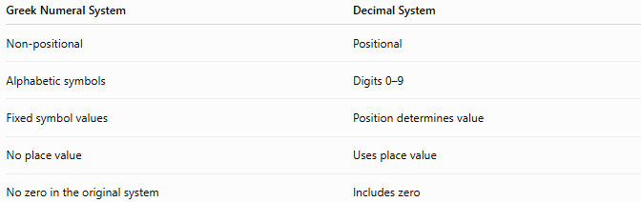
Greek Numeral System | Decimal System
Non-positional | Positional
Alphabetic symbols | Digits 0–9
Fixed symbol values | Position determines value
No place value | Uses place value
No zero in the original system | Includes zero

Greek Numeral System vs. Roman Numerals
# Source: AI Source: Provided by: [Data Path: Persons Table -> ID Column: 1, Name_En Column: Motasem Essam] -> From: [ChatGPT] on [7/16/2026]
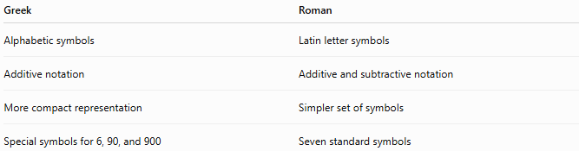
Greek | Roman
Alphabetic symbols | Latin letter symbols
Additive notation | Additive and subtractive notation
More compact representation | Simpler set of symbols
Special symbols for 6, 90, and 900 | Seven standard symbols

Greek Numeral System vs. Egyptian Numerals
# Source: AI Source: Provided by: [Data Path: Persons Table -> ID Column: 1, Name_En Column: Motasem Essam] -> From: [ChatGPT] on [7/16/2026]
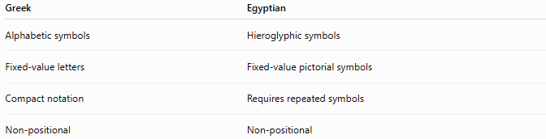
Greek | Egyptian
Alphabetic symbols | Hieroglyphic symbols
Fixed-value letters | Fixed-value pictorial symbols
Compact notation | Requires repeated symbols
Non-positional | Non-positional

Conclusion
# Source: AI Source: Provided by: [Data Path: Persons Table -> ID Column: 1, Name_En Column: Motasem Essam] -> From: [ChatGPT] on [7/16/2026]
The Greek Numeral System is a non-positional numeral system that represents numbers using letters of the Greek alphabet, each assigned a fixed numerical value. Numbers are formed by adding the values of the letters, without using place value or a positional base. The Ionic (Milesian) system became the standard Greek numeral system and played an important role in ancient mathematics, astronomy, commerce, and literature. Although it has been replaced by modern positional numeral systems for everyday calculation, it remains historically significant and is still encountered in scholarly, historical, and traditional contexts.

